Team Nomz

Milestone 3 Part a

**Part 1a:**

Our survey was distributed on Amazon Mechanical Turk to people who are both in the United States and have achieved Amazon Master Turker status. There are overall 199 participants who have filled out the survey. Most participants are between 25-34 years old, female, white, and have an income less than $40,000. Detailed demographic distribution graphs are displayed below. One key aspect to mention is that the demographics of survey participants do not match with the demographics of Nomz’s target customers, especially in the term of income levels. However, we believe this demographic discrepancy is not a major issue because most of the questions ask about customer’s perceptions of the website’s design elements, instead of their view of the company or concept.

The mean value, range, and standard deviation for each design elements are displayed below.

|  |  |  |  |  |
| --- | --- | --- | --- | --- |
| **Functionality** | **Mean** | **SD** | **Max** | **Min** |
| How quickly pages load | 8.527918782 | 1.673771933 | 10 | 1 |
| Ease of making a purchase | 8.258883249 | 1.593668842 | 10 | 3 |
| How interactive is the website | 7.700507614 | 1.658819886 | 10 | 1 |
| Ease of finding the product you were looking for | 7.593908629 | 2.07452071 | 10 | 2 |
| Ease of navigating and browsing | 8.30964467 | 1.702506668 | 10 | 3 |
| Overall functionality of the website | 8.397959184 | 1.379258782 | 10 | 3 |
|  |  |  |  |  |
| **Visual** |  |  |  |  |
| Helpfulness of the website's layout | 7.849740933 | 1.913007132 | 10 | 1 |
| Appealing nature of the website's graphics | 8.766497462 | 1.589600905 | 10 | 2 |
| Helpfulness of the product images provided | 8.598984772 | 1.445118096 | 10 | 3 |
| Appealing nature of the website's font styles | 8.411167513 | 1.521437678 | 10 | 3 |
| Amount of content per page | 7.624365482 | 2.033147562 | 10 | 1 |
| Overall satisfaction of the website's visual appearance | 8.367346939 | 1.709027344 | 10 | 1 |
|  |  |  |  |  |
| **Informational** |  |  |  |  |
| Usefulness of information on how the business works | 8.284263959 | 1.622672931 | 10 | 2 |
| Usefulness of product descriptions provided | 8.294416244 | 1.503268307 | 10 | 4 |
| Usefulness of product customer reviews provided | 5.807106599 | 2.814566747 | 10 | 1 |
| Ease of reading product description | 8.294416244 | 1.503268307 | 10 | 4 |
| Ease of accessing customer reviews | 5.152284264 | 3.04174315 | 10 | 1 |
| Overall usefulness of information provided | 8.030456853 | 1.534995278 | 10 | 3 |
|  |  |  |  |  |
| **General** |  |  |  |  |
| Overall trustworthiness of the website | 8.279187817 | 1.484004287 | 10 | 3 |
| Overall level of satisfaction with the website | 8.208121827 | 1.45417591 | 10 | 2 |

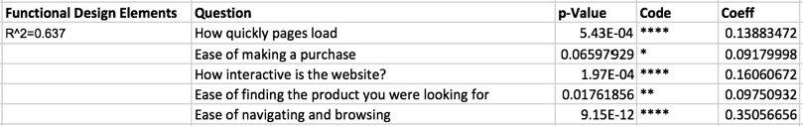



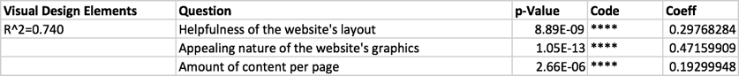

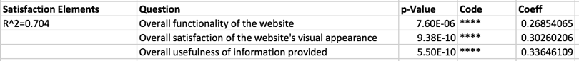

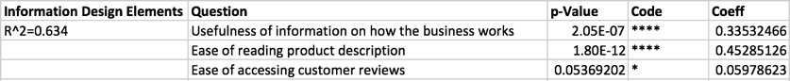

Overall, the website receives high rating in most of the design elements. The websites’ graphic is particularly appealing, with average score of 8.77. The helpfulness of the website (8.59) and the ease of navigating and browsing (8.31) are other two aspects that the website does particularly well on. In a category level, there does not seem to be significant weaknesses. However, we did learn that functionality is not a significant predictor to Nomz’s trustworthiness.

The website, however, needs to improve its review elements. The website received a significantly lower score on “usefulness of the reviews” and “easiness of accessing customer reviews” (5.81 and 5.15, respectively). Even though reviews are at most a weak predictor of the overall information design rating (coef = .060, p = .05), we believe difficulty accessing reviews will harm users’ overall experiences and decrease Nomz’s brand equity. Furthermore, making reviews more accessible to customers will only benefit Nomz since most customers gave five star reviews.

We have additionally performed a text analytics of the comment section of the survey. The result shows that functionally, most commenters believes that the website does not offer a straight forward structure for the products and services to be explained clearly, and the page structure of the website is also preventing the website from becoming more functional. Visually, the layout of the navigation bar is preventing eatnomz.com from becoming more visually appealing. Finally, in regards to informational design, Nomz’s front page layout is inhibiting information from being delivered effectively.

**Part 1b: Website Design Recommendations**

Overall, according to the results from our survey, eatnomz.com is well-designed. However, we do identify one critical area of improvement and several recommended areas improvements to eatnomz.com. Major recommendations are accompanied with several alternatives for our client to choose from. A table of that displayed projected implementation complexities, rewards, and risks is also attached below to further help our clients through the decision process.

*Critical Improvements:*

Reviewers have scored the usefulness and accessibility of eatnomz.com’s reviews significantly lower compare with other design elements. In order to improve both the accessibility and usefulness of eatnomz.com’s reviews, we have offered below recommendations.

1. Adding a review section after product descriptions on the home page.
   1. Alt1: Provide a snapshot of the reviews on the first section of the home page.
   2. Alt2: Provide a snapshot of the reviews right after the first section of the home page.
2. Placing an average-review-star image before add-to-cart on both the home page and product page. Users will be directed to the review section below the product descriptions after clicking on the image.
3. Provide one additional navigation bar selection in the header – “Review”, which directs to a dedicated review page.

*Recommended Improvements:*

Reviewers also rated “Helpfulness of website’s layout”, “Ease of finding the product”, and “Amount of content per page” slightly lower than other design elements. Solutions presented below are designed to improve either one or multiple design elements on eatnomz.com. Some solutions are also geared to resolve specific concerns identified in the results of the comment text analysis.

1. Remove detailed product descriptions on the home page. Instead, provide direct links to detailed product descriptions and the add-to-cart button.
   1. Alt1: Provide links to detailed product description and add-to-cart button in the second section of the home page, right after the starting image.
   2. Alt2: Remove all information on the home page except for the product display (with Learn more and Add to Cart button), and the first section.
2. Improve the navigation bar so it does not stack on a desktop screens under any conditions. This could be accomplished by either reducing the founder in current headers, or creating a hierarchy of navigation bars.
3. Provide one additional navigation bar selection in the header– “Product” which directs to the product page.
4. Add “Learn More” and “Add to Cart” icons on the product collection page.

|  |  |  |  |  |
| --- | --- | --- | --- | --- |
| **Improvement #** | **Solution Complexity** | **Solution Risk** | **Solution Reward** | **Additional Comments** |
| **Critical** |  |  |  |  |
| 1 | Low | Low | Low | Already done in product page, does not change customer experiences significantly. |
| 1.Alt1 | Medium | Medium | High | Change in customer experiences. Need theme modification. Make reviews much easier to access. |
| 1.Alt2 | Medium | Low | Medium | Need to investigate partial comment functionality. But will improve overall layout. |
| 2 | Medium | Low | Medium | Need to change template. |
| 3 | Low | Low | Low | Modifiable through Shopify interface. |
| **Recommended** |  |  |  |  |
| 1 | Medium-High | Medium-High | Medium-High | Significant change in homepage content, need intensive template changes. But improve page content and tidiness dramatically. |
| 1.Alt1 | Medium-High | High | High | Change in customer experiences, but makes product much more accessible. |
| 1.Alt2 | Medium-High | Very High | Very High (potentially) | Makes product layouts most accessible, page most tidy and concise. Least content on page. |
| 2 | Medium | Low | Low | Making navigation bar more appealing visually. Need to investigate cross-device template. |
| 3 | Low | Low | Low | Modifiable through Shopify interface. |
| 4 | Medium | Low | Medium | Need to modify collection template. |

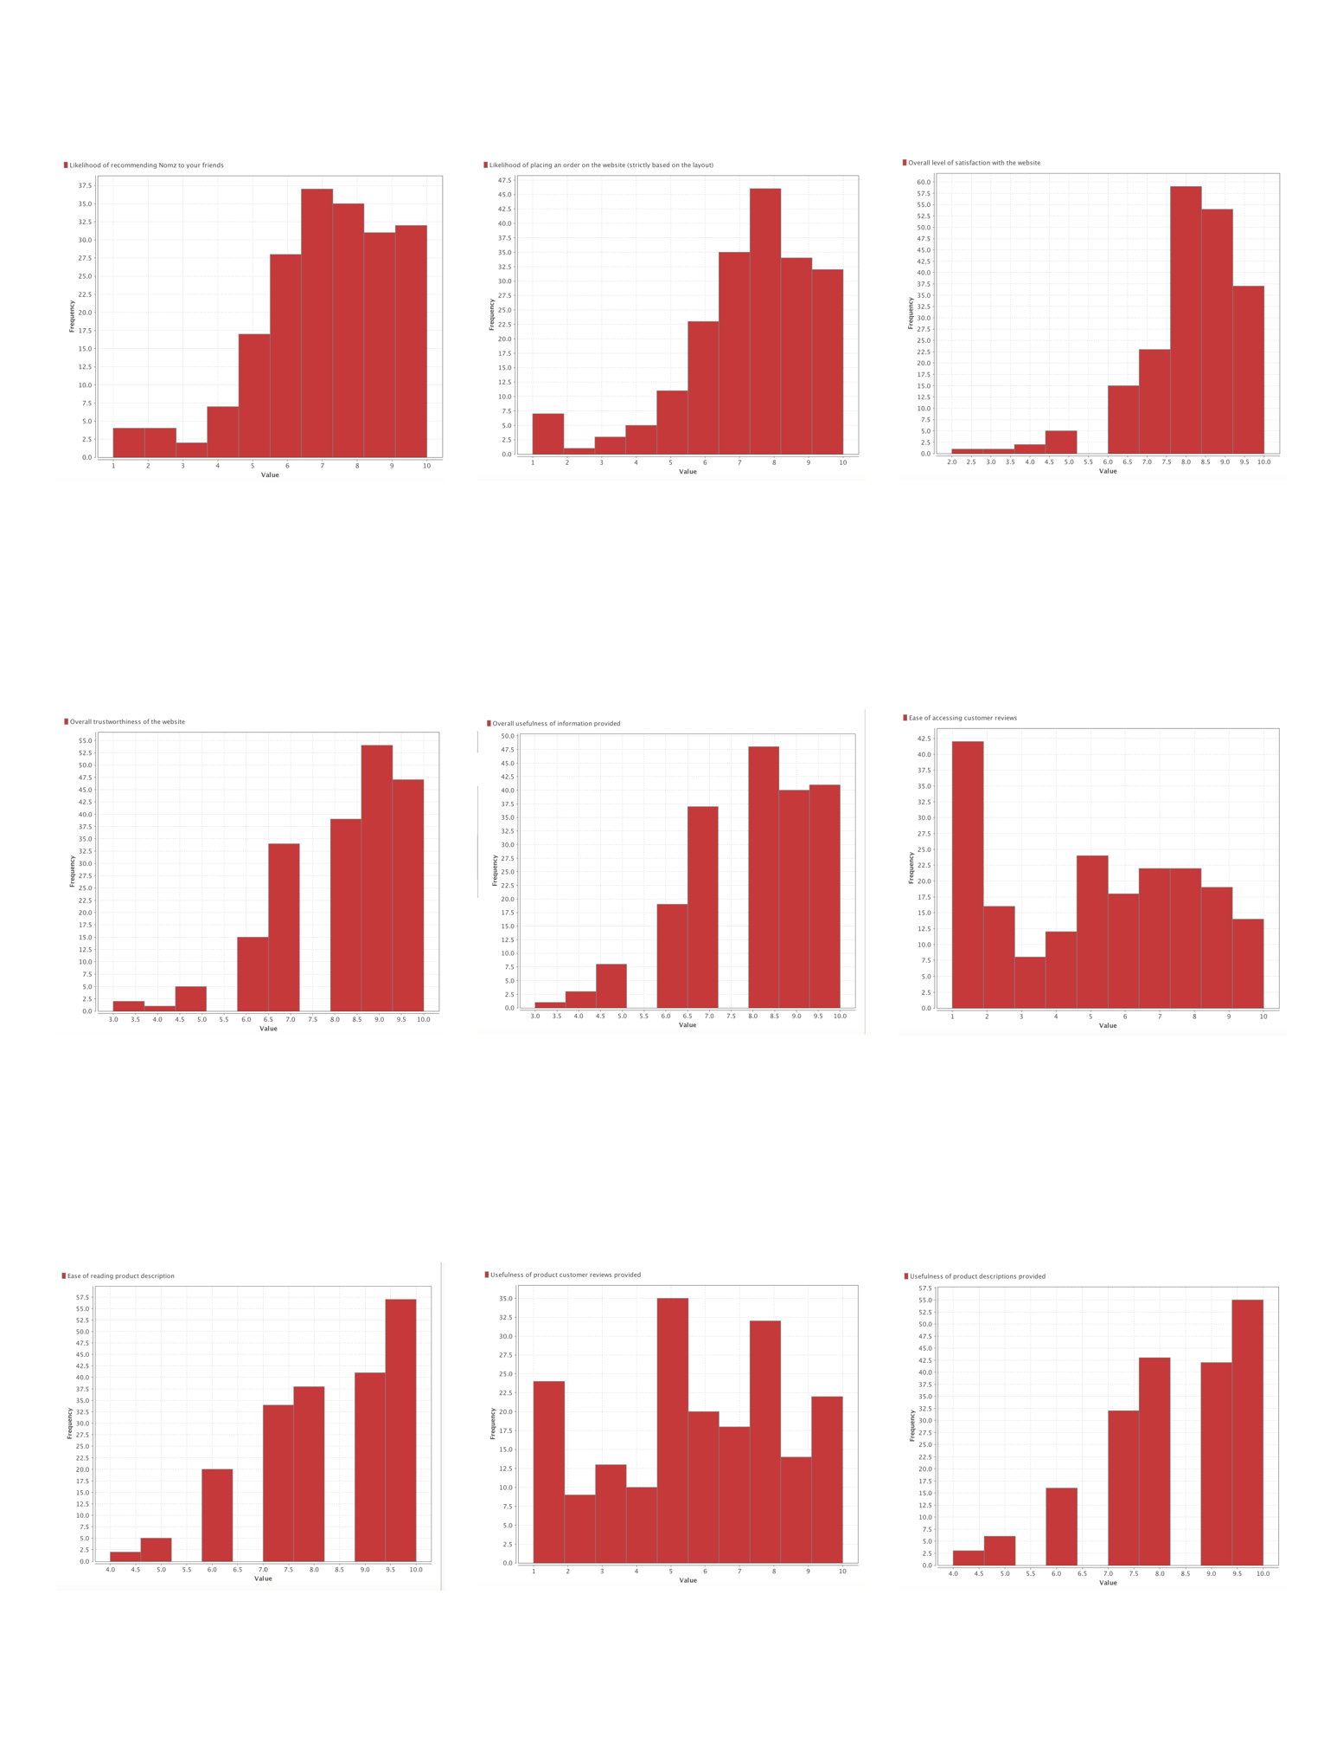Appendix A: Histograms of all design elements

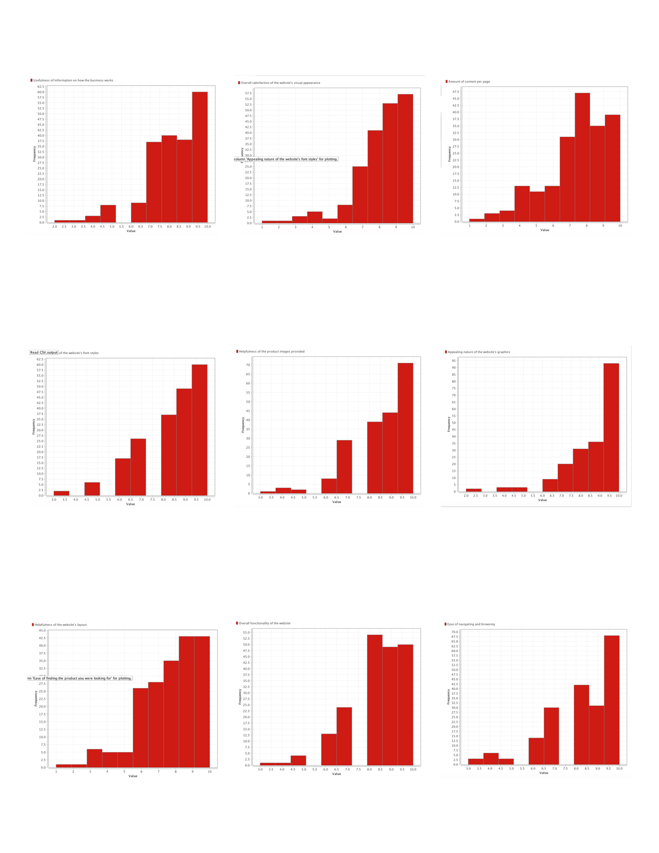

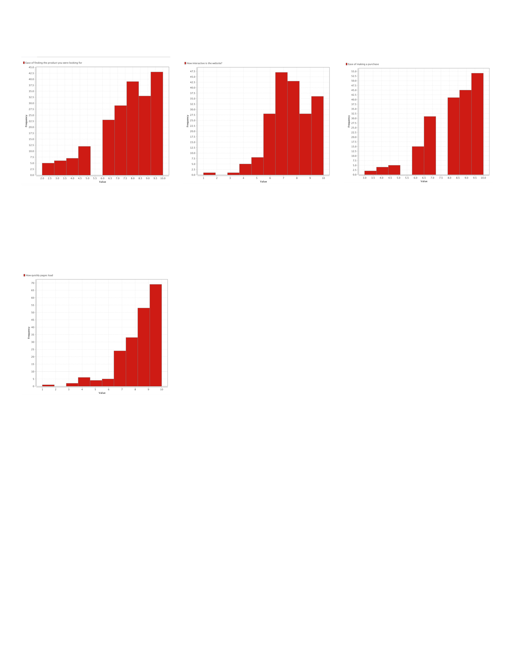

Appendix B: Regression Results for CRO Model

|  |  |  |  |  |  |  |  |  |
| --- | --- | --- | --- | --- | --- | --- | --- | --- |
| **Functional Design Elements** | **Question** | **Coeff** | **Std. Error** | **Std. Coeff** | **Tolerance** | **t-Stat** | **p-Value** | **Code** |
| R^2=0.637 | How quickly pages load | 0.138834721 | 0.039460701 | 0.168875688 | 0.849948756 | 3.518303509 | 5.43E-04 | **** |
|  | Ease of making a purchase | 0.091799976 | 0.049643995 | 0.106319618 | 0.608703817 | 1.849165757 | 0.065979295 | * |
|  | How interactive is the website? | 0.160606722 | 0.042309523 | 0.193613532 | 0.742985439 | 3.795994582 | 1.97E-04 | **** |
|  | Ease of finding the product you were looking for | 0.09750932 | 0.040725279 | 0.147006542 | 0.552520517 | 2.39431928 | 0.017618557 | ** |
|  | Ease of navigating and browsing | 0.350566563 | 0.048242823 | 0.433742591 | 0.561974302 | 7.266709166 | 9.15E-12 | **** |
|  | (Intercept) | 1.563488844 | 0.411883774 | NaN | NaN | 3.795946677 | 1.97E-04 | **** |
|  |  |  |  |  |  |  |  |  |
| **Visual Design Elements** | **Question** | **Coeff** | **Std. Error** | **Std. Coeff** | **Tolerance** | **t-Stat** | **p-Value** | **Code** |
| R^2=0.740 | Helpfulness of the website's layout | 0.297682841 | 0.049471578 | 0.330621314 | 0.454803925 | 6.017249779 | 8.89E-09 | **** |
|  | Appealing nature of the website's graphics | 0.471599085 | 0.058816802 | 0.439715315 | 0.497714077 | 8.018101401 | 1.05E-13 | **** |
|  | Helpfulness of the product images provided | -0.025941439 | 0.05858725 | -0.021989125 | 0.677784828 | -0.442783016 | 0.658423738 |  |
|  | Appealing nature of the website's font styles | 0.028152449 | 0.060566587 | 0.025123543 | 0.582683986 | 0.464818158 | 0.642591133 |  |
|  | Amount of content per page | 0.19299948 | 0.039867129 | 0.230163036 | 0.660984081 | 4.84106791 | 2.66E-06 | **** |
|  | (Intercept) | 0.408345154 | 0.426479465 | NaN | NaN | 0.957479052 | 0.339535888 |  |
|  |  |  |  |  |  |  |  |  |
| **Information Design Elements** | **Question** | **Coeff** | **Std. Error** | **Std. Coeff** | **Tolerance** | **t-Stat** | **p-Value** | **Code** |
| R^2=0.634 | Usefulness of information on how the business works | 0.335324663 | 0.062202625 | 0.354478128 | 0.533344534 | 5.390844208 | 2.05E-07 | **** |
|  | Usefulness of product descriptions provided | 0.042779895 | 0.069434079 | 0.041895673 | 0.488354164 | 0.616122453 | 0.538547276 |  |
|  | Usefulness of product customer reviews provided | 0.044502926 | 0.034056055 | 0.081600548 | 0.849100064 | 1.306755191 | 0.192867056 |  |
|  | Ease of reading product description | 0.452851265 | 0.060026364 | 0.443491236 | 0.593208988 | 7.544206091 | 1.80E-12 | **** |
|  | Ease of accessing customer reviews | 0.059786232 | 0.030796835 | 0.118472261 | 0.956393501 | 1.941310892 | 0.053692025 | * |
|  | (Intercept) | 0.575098795 | 0.435263551 | NaN | NaN | 1.321265688 | 0.187993392 |  |
|  |  |  |  |  |  |  |  |  |
| **Trustworthiness Elements** | **Question** | **Coeff** | **Std. Error** | **Std. Coeff** | **Tolerance** | **t-Stat** | **p-Value** | **Code** |
| R^2=0.733 | Overall functionality of the website | 0.101187295 | 0.083598011 | 0.093824892 | 0.502673034 | 1.210403139 | 0.227604504 |  |
|  | Overall satisfaction of the website's visual appearance | 0.27896823 | 0.067323471 | 0.320485994 | 0.519987983 | 4.143699472 | 5.11E-05 | **** |
|  | Overall usefulness of information provided | 0.307868615 | 0.073733818 | 0.318447105 | 0.531550799 | 4.175405821 | 4.50E-05 | **** |
|  | (Intercept) | 2.623596057 | 0.527644763 | NaN | NaN | 4.972277265 | 1.46E-06 | **** |
|  |  |  |  |  |  |  |  |  |
|  |  |  |  |  |  |  |  |  |
|  |  |  |  |  |  |  |  |  |
| **Satisfaction Elements** | **Question** | **Coeff** | **Std. Error** | **Std. Coeff** | **Tolerance** | **t-Stat** | **p-Value** | **Code** |
| R^2=0.704 | Overall functionality of the website | 0.268540651 | 0.058365237 | 0.254109168 | 0.502657142 | 4.601037615 | 7.60E-06 | **** |
|  | Overall satisfaction of the website's visual appearance | 0.302602064 | 0.047002916 | 0.354767971 | 0.50729637 | 6.437942312 | 9.38E-10 | **** |
|  | Overall usefulness of information provided | 0.336461088 | 0.051478399 | 0.355160733 | 0.520589543 | 6.535966405 | 5.50E-10 | **** |
|  | (Intercept) | 0.720122436 | 0.368383306 | NaN | NaN | 1.954818323 | 0.052048715 | * |

Appendix C: Text Analysis Information Gain and Analysis Graphs

We have parsed all comments and weighted them by information gain based on Functional Design, Informational Design, and Visual Design elements. After weighting them by information gain, we graphed out multiple high information gain variables and examined whether each individual word have abnormal distribution in terms of high and low design ratings. Those graphs, along with information gain tables of each design elements, are displayed below.

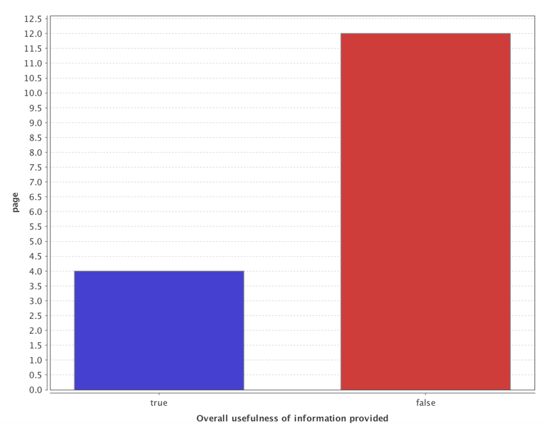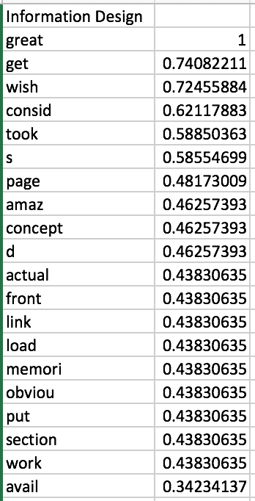

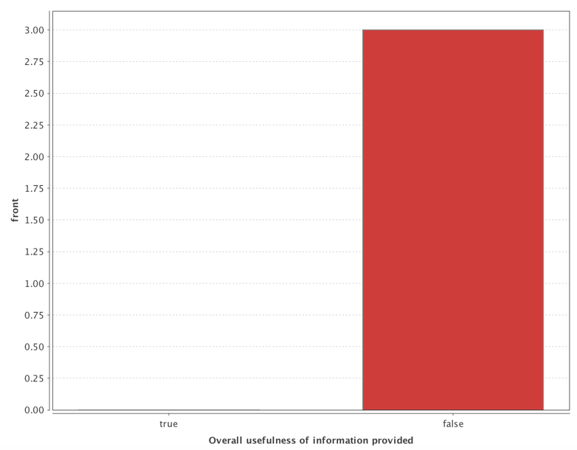

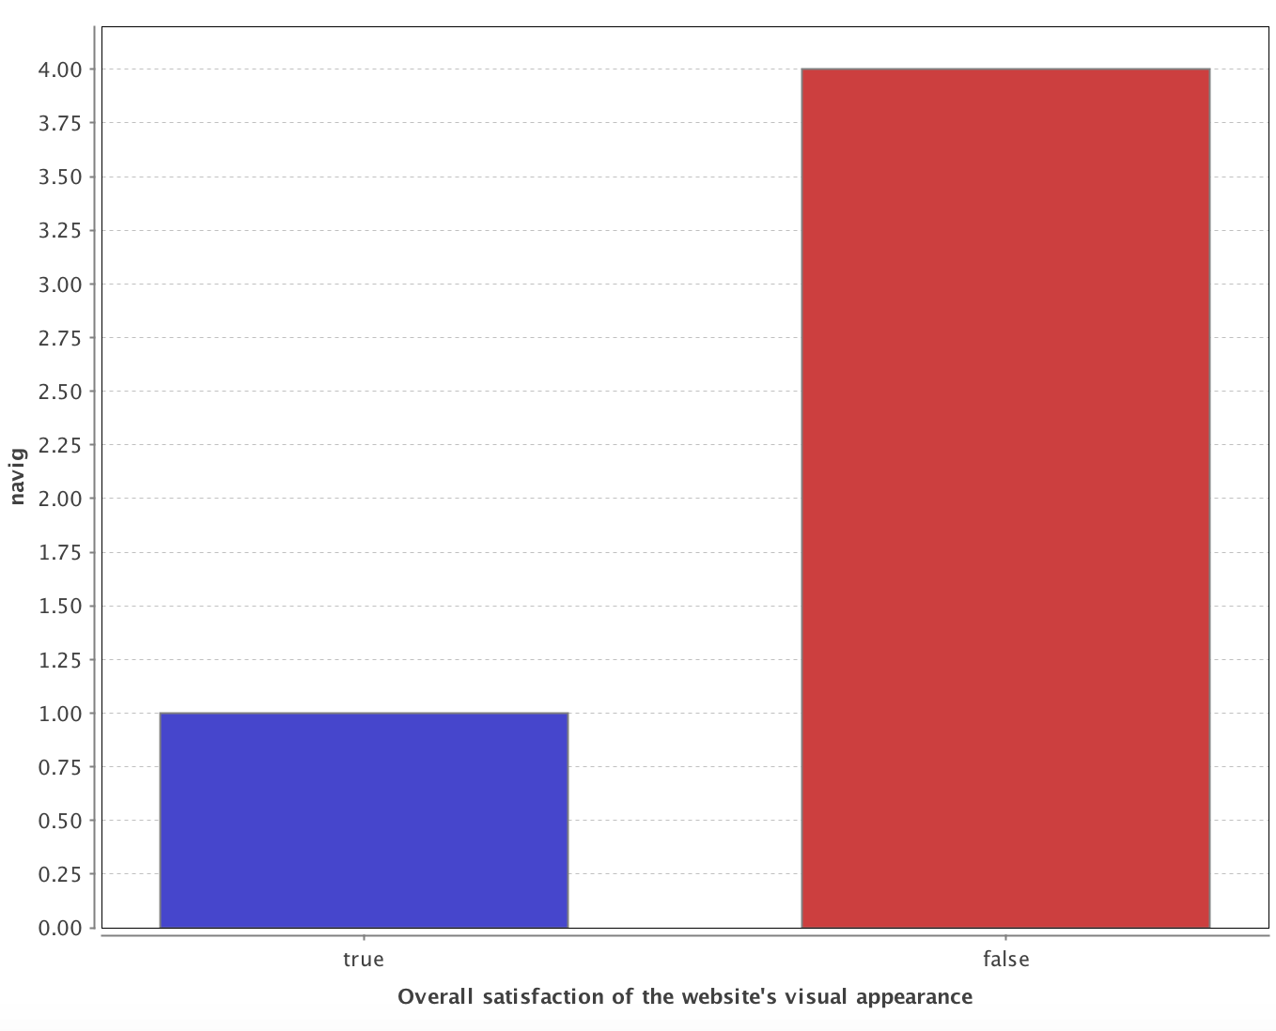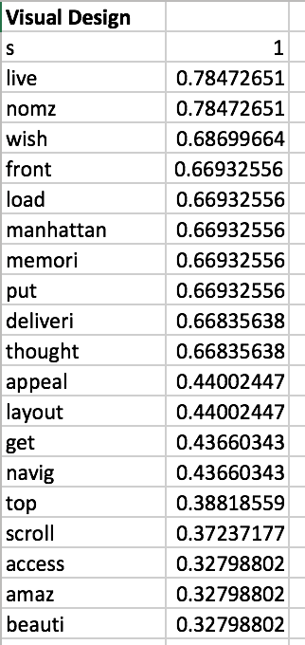

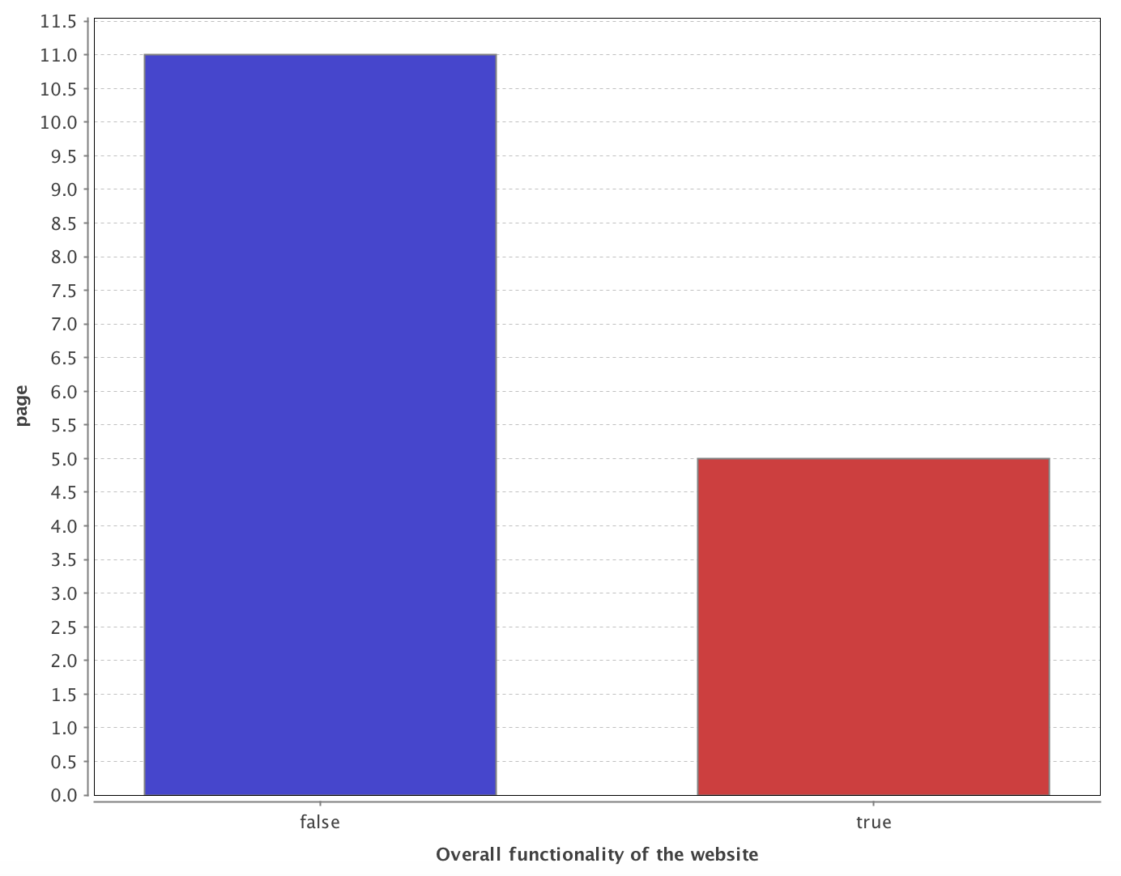

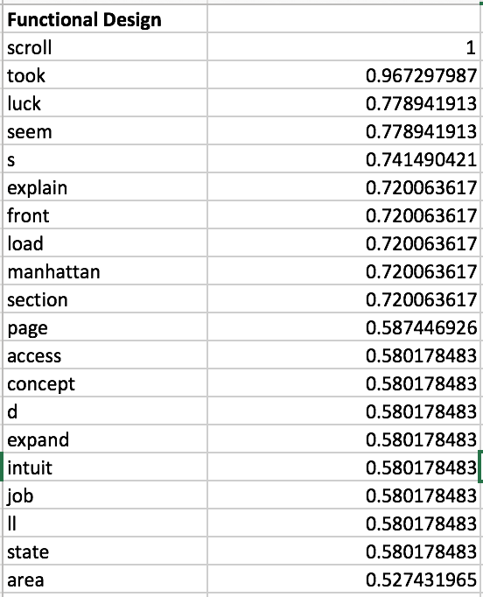

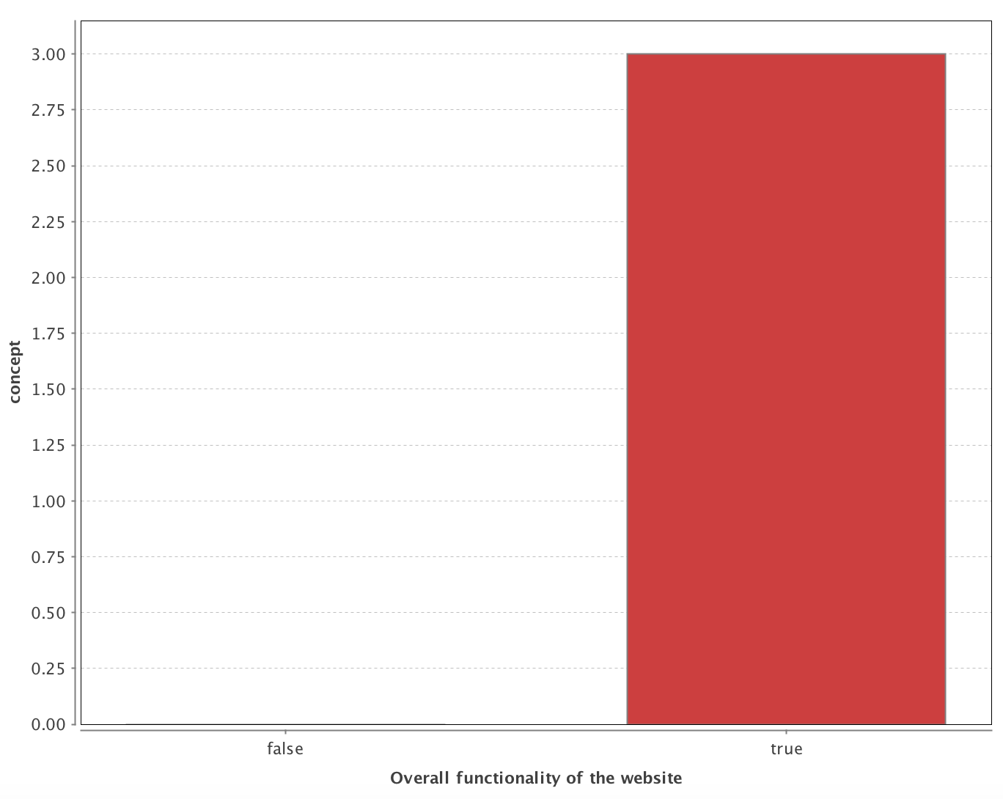

Appendix D: Solution Visualization for Selected Recommendations.

**Critical Recommendations 1**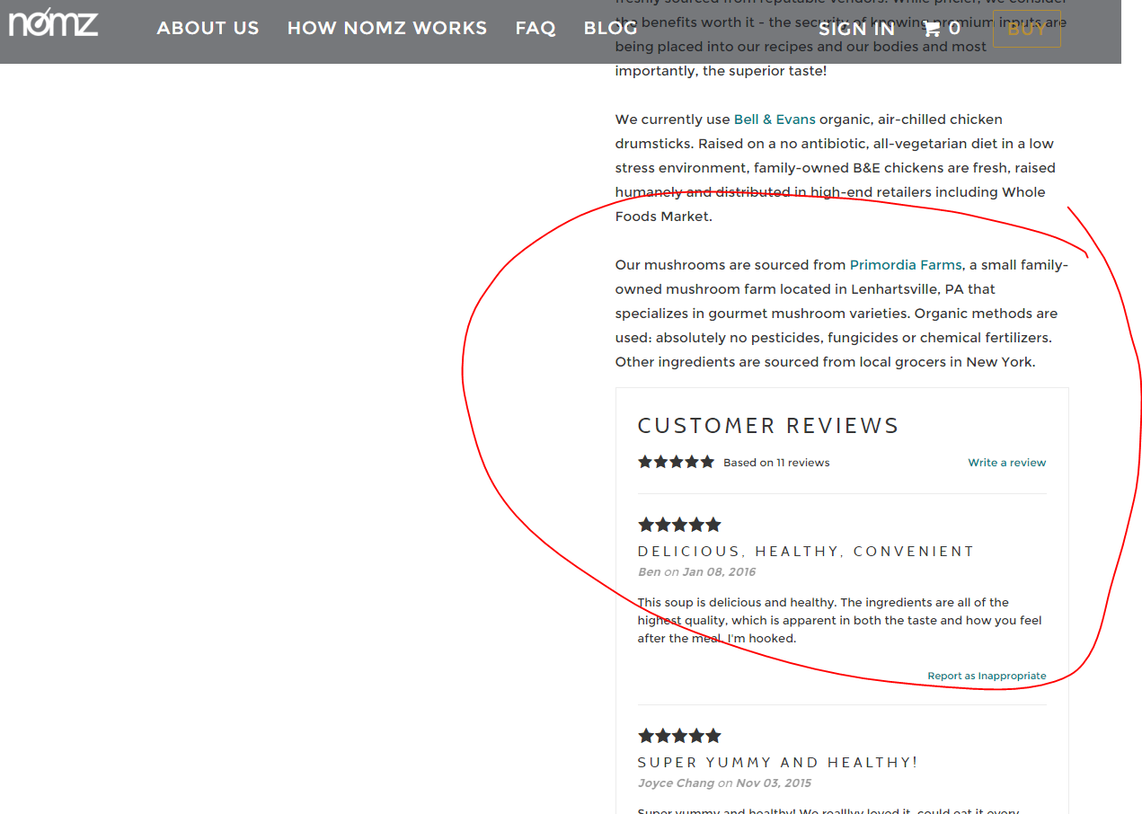

**Critical Implementation 1 Alternative 1**

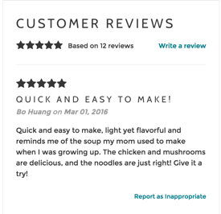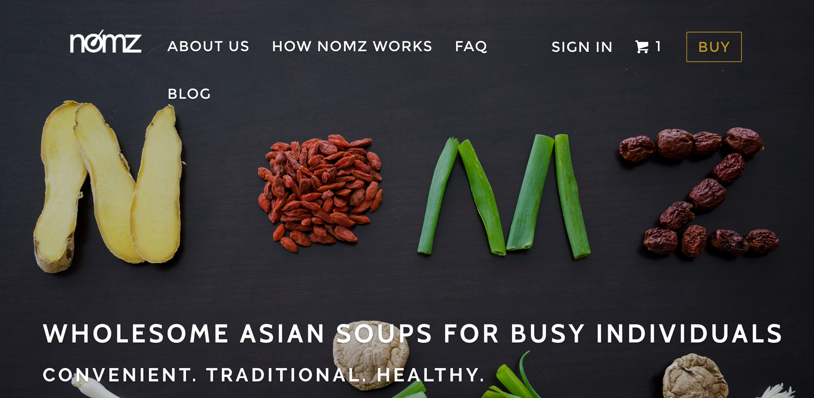

**Critical Implementation 1 Alternative 2**

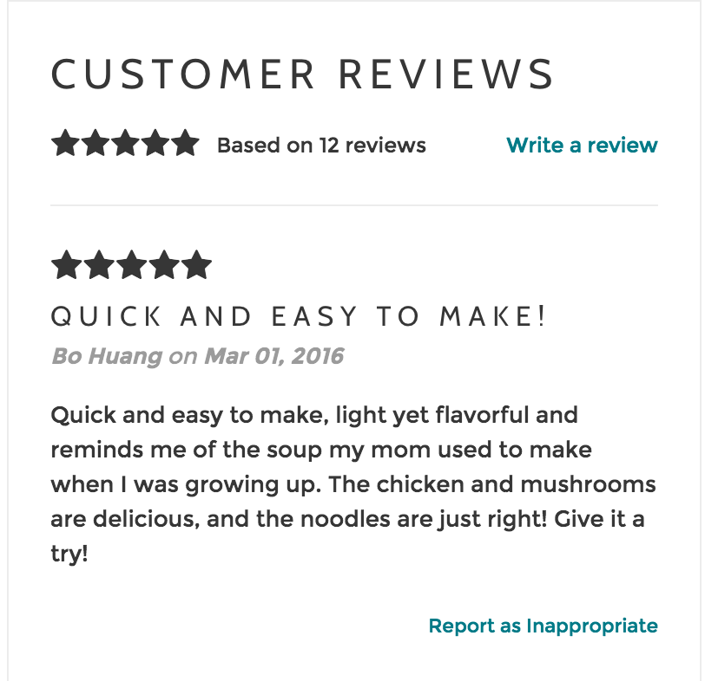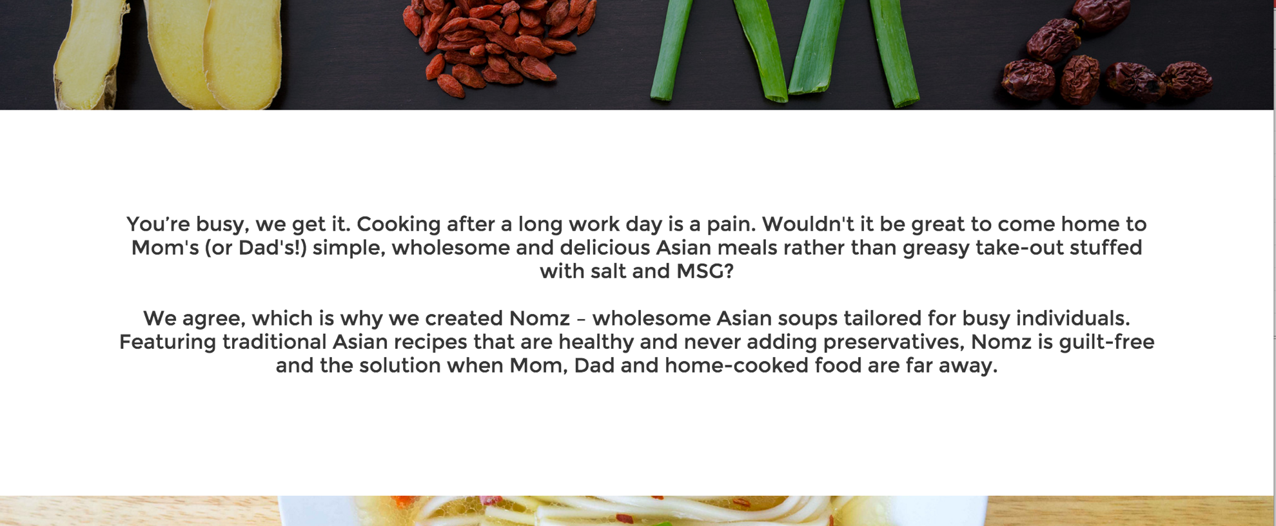

**Critical Implementation 2**

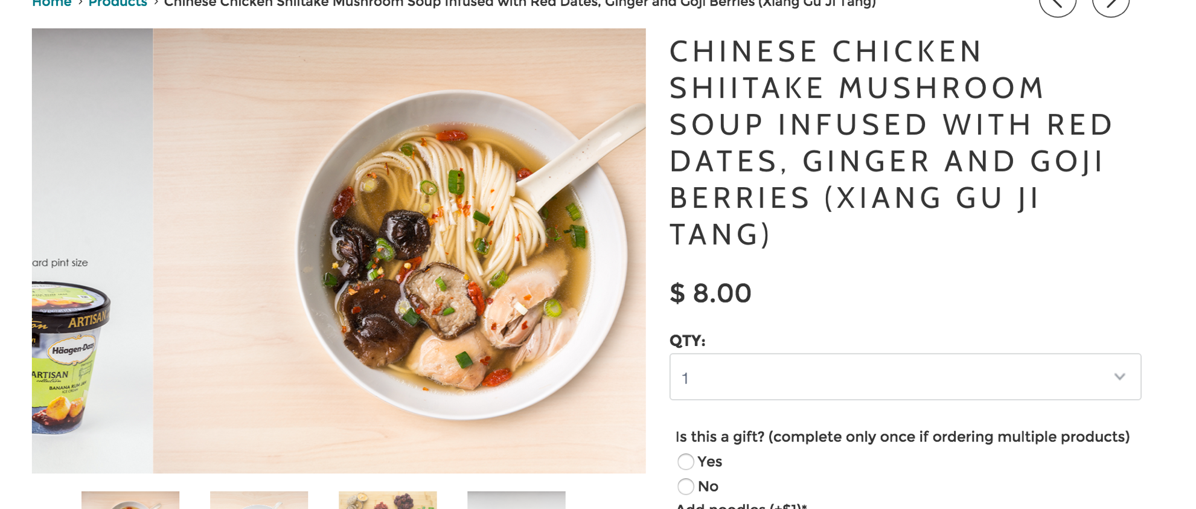

**Critical Implementation 3**



Reviews

**Recommended Implementation 1**

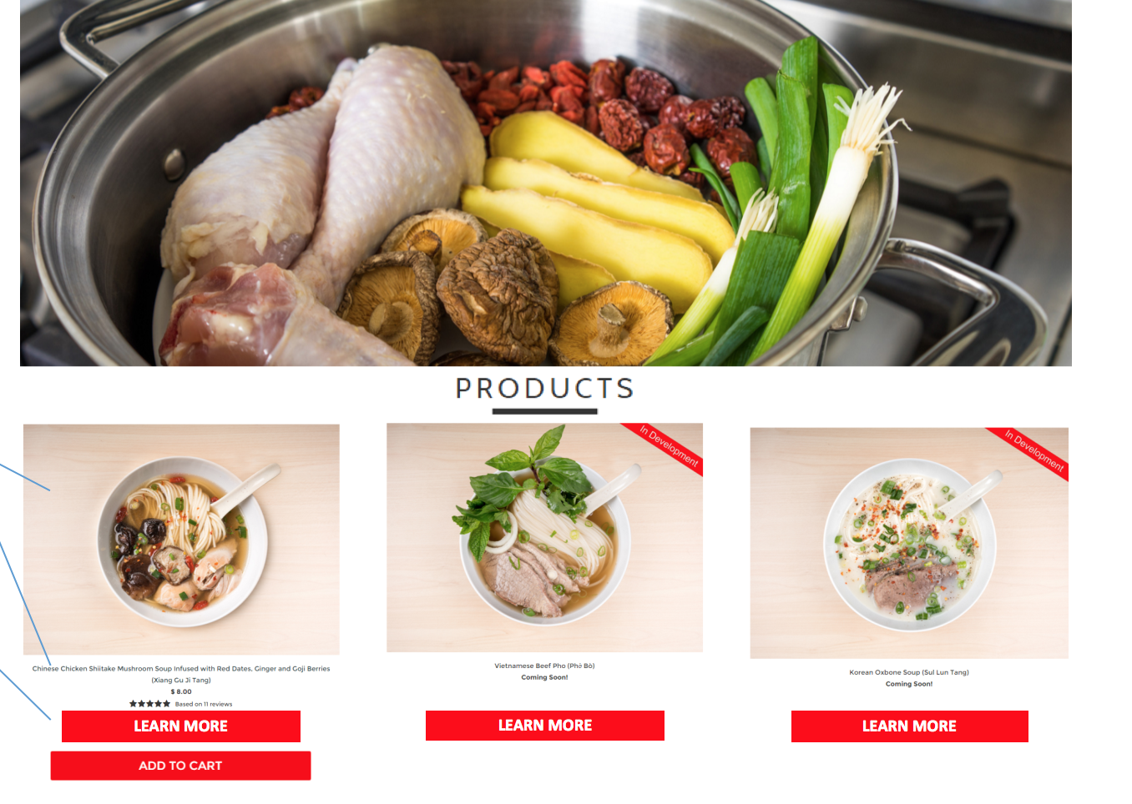

**Recommended Implementation 1 Alternative 1 and 2 (in 2 this will be the end of the page) as well as illustration for Recommended Implementation 4’s product page.**



**Recommended Implementation 2 (current state)**



**Recommended Implementation 3 + Recommended Implementation 2 (Proposed State (rough sketch))**

Blogs



Products

Reviews